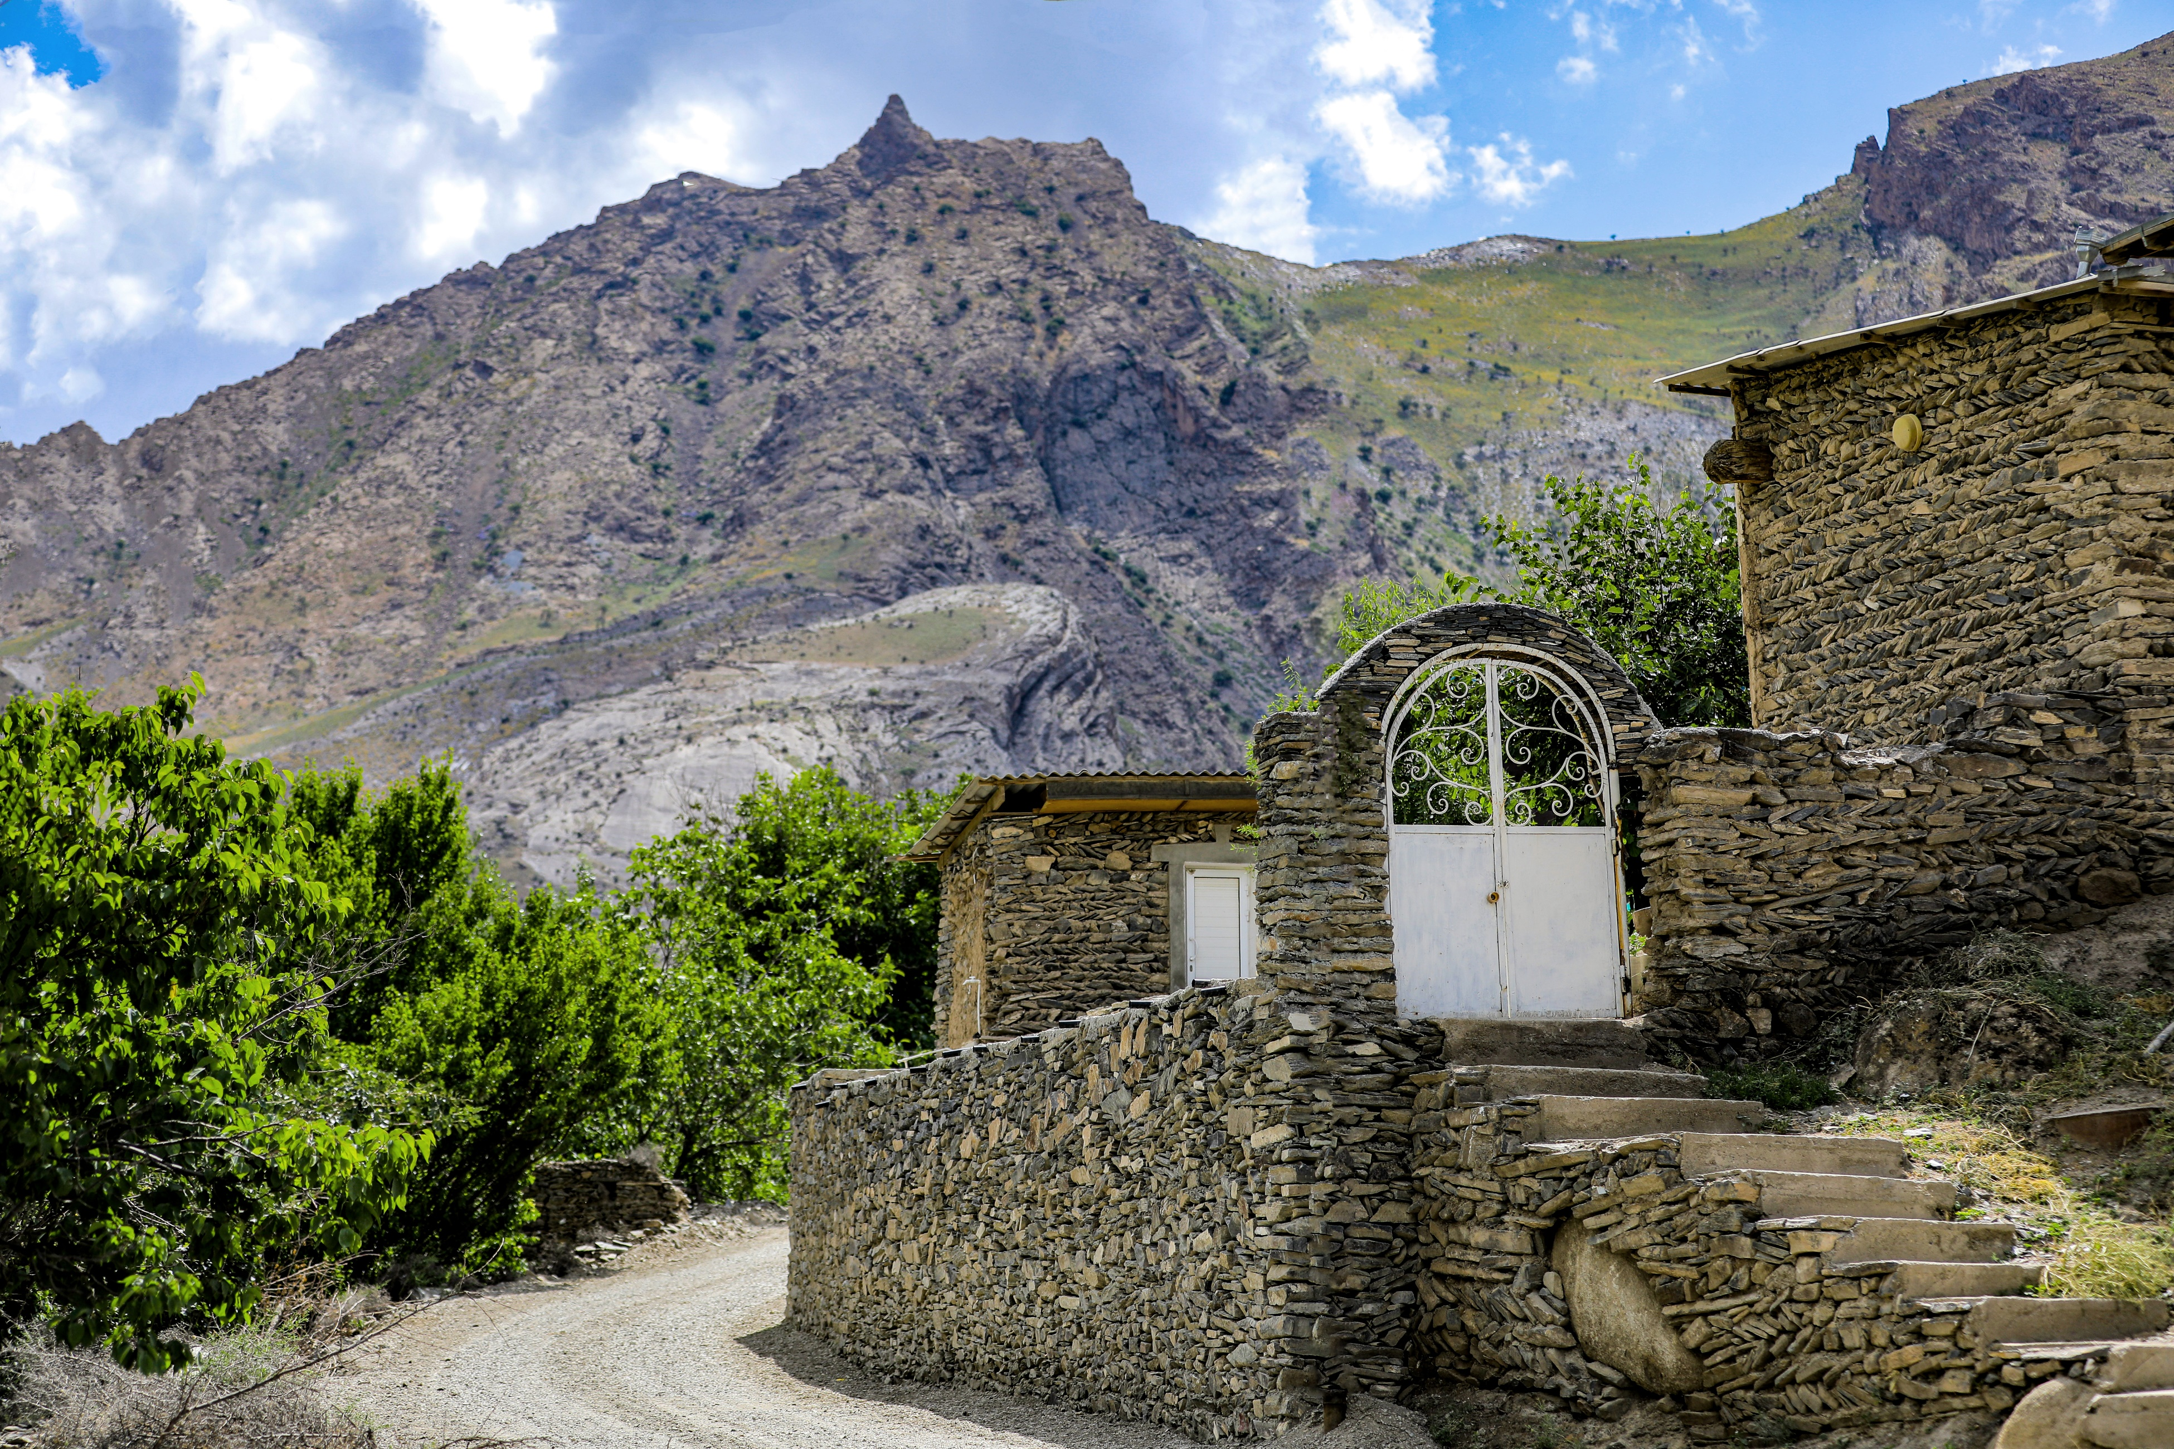
Best Tourism Villages
by UN Tourism

Application Form
2024 Edition

Best
Tourism Villages
by UN Tourism

Application Form
2024 Edition
January 2024

Application Form

Before you submit your application, we invite you to carefully read the following documents (available at http://www.unwto.org/tourism-villages/en/the-initiative/):
- Terms and Conditions
- Guidelines for Application
- Areas of Evaluation
- Candidacy Document
- General Presentation Template
- Copyrights Template

IMPORTANT NOTES:
- All applications must be submitted online.
- All documents must be submitted in the format specified in the online application form and must not exceed the maximum length and/or size indicated. The title of each document should reflect the contents of the document.
- Make sure to have all mandatory documents ready for upload before submitting your application. Incomplete and/or late applications shall not be considered.
- Once an application is submitted, no changes can be made. The submitted application will be considered as the final version.
- Deadline for applications is 24 April 2024 (23:59 CEST). Deadline has been extended to 8 May 2024 (23:59 CEST).
- All fields marked with an asterisk (*) are mandatory.

Basic Information

- Name of the village* | Please make sure to write the exact name of the village in Latin alphabet including accents/special characters as applicable (the name must correspond to the name in the census evidence provided) | Open-ended Question
- Name of the village (original language) | Please provide the name of the village in your native language characters (if different from the above) | Open-ended Question
- Country* |  | Drop-down Question
- Region/ province/ prefecture/ municipality* | Sometimes, there can be more than one village with the same name in the country. Please, insert the name of the region, province, prefecture, municipality or other relevant geographic or administrative indications to help us identify the village. | Open-ended Question
- Geographical Coordinates of the village*:  - Latitude  - Longitude | Please use the format "latitude, longitude" with decimal degrees, ensuring that latitude ranges from -90 to 90 and longitude from -180 to 180. The coordinates should be indicated following the format below (example):  Latitude: 40.7128  Longitude: -74.0060 | 2 open-ended questions. Numeric values only.
- Population of the village (number of inhabitants) * | Considering that a maximum of 15.000 inhabitants is an eligibility pre-requisite, please indicate the number of inhabitants. | Open-ended Question
Submit/provide a supporting document of the population census for the village for the latest year available.* |  | File upload
- Extent of the village’s territory (in square km) |  | Open-ended Question
  - Contact information for representative in the village.
The contact provided will be the representative for all communications with UN Tourism.
- Title (Mr/Ms/Other)* |  | Field Questions
    - Family Name*
    - First Name*
    - Institution*
    - Position*
    - Street Address and Number*
    - State/Province*
    - Postal/Zip Code*
    - Area Code + Telephone Number*
    - E-mail Address*
  - Contact information for the responsible for the application at the UN Tourism Member State
The responsible for the application of the village will be the representative of the UN Tourism Member State. This person will be responsible for the communication and coordination of all issues related to the candidacy.
- Title (Mr/Ms/Other)* |  | Field Questions
    - Family Name*
    - First Name*
    - Institution*
    - Position*
    - Street Address and Number*
    - State/Province
    - Postal/Zip Code
    - Area Code + Telephone Number*
    - E-mail Address*
  - Details on online promotion channels (website and Social Media)
If any, please provide the name of the following specific accounts for the village:
- Website |  | Field Questions
    - Instagram
    - X (Twitter)
    - LinkedIn
    - Facebook
    - Other

- Key Tourism Data
For further information on definitions on visitors, tourism products, etc., kindly refer to the UNWTO Glossary of Tourism Terms and to the International Recommendations for Tourism Statistics 2008 (IRTS 2008)

  - Visitors
If available, we kindly ask you to provide the following for the last 5 years or the ones available in any of the years from that period.
Data | 2019 | 2020 | 2021 | 2022 | 2023
Total number of overnight visitors (total tourists)
Total number of same-day visitors (excursionists)

  - Tourism products and tourism related businesses

Data | Number | Year of reference
Total number of tourism businesses in the village
Total number of rooms available in the village (accommodation capacity)

Main tourism products/experiences:

Please, use the box below to list the main types of tourism products offered by the village:

(You can refer to UNWTO Tourism Definitions to check some examples on types of tourism)

- Open text. Open field question
- Motivation and Areas of Evaluation

- Please upload a short video either in English or Spanish telling us why the village should become a Best Tourism Village by UN Tourism. The video should be tailored to this purpose (unedited simple shot taken with a smartphone is sufficient). A general promotional video is not accepted. *  Format and limit specified: mp4 format, 2min max., 30MB max. | File upload field
- Please upload a general presentation following the structure provided in the template “General Presentation”. *  Format and limit specified: PDF format, 12 slides max, 20MB max. | File upload field
- Please upload the document “Candidacy Document” completed. *  Format and limit specified: PDF format, limit specified in the number of words allowed per question, 20MB max. | File upload field
- Please choose up to five (5) Sustainable Development Goals (SDGs) that, as of 2024, the village has prioritized for focused efforts through tourism. Only select the goals that the village has explicitly decided to work towards in its plans or efforts. *  (Kindly refer to the SDGs website for guidance)  GOAL 1: No Poverty ☐  GOAL 2: Zero Hunger ☐  GOAL 3: Good Health and Well-being ☐  GOAL 4: Quality Education ☐  GOAL 5: Gender Equality ☐  GOAL 6: Clean Water and Sanitation ☐  GOAL 7: Affordable and Clean Energy ☐  GOAL 8: Decent Work and Economic Growth ☐  GOAL 9: Industry, Innovation and Infrastructure ☐  GOAL 10: Reduced Inequality ☐  GOAL 11: Sustainable Cities and Communities ☐  GOAL 12: Responsible Consumption and Production ☐  GOAL 13: Climate Action ☐  GOAL 14: Life Below Water ☐  GOAL 15: Life on Land ☐  GOAL 16: Peace, Justice and Strong Institutions ☐  GOAL 17: Partnerships for the Goals ☐ | Selection field

Supporting Visual Files
- Please upload relevant supporting visual files that are relevant to showcase the village resources and initiatives.*  Format and limit specified:  Images: jpg. Up to 10 images. 20MB per file max.  Videos: mp4. Up to 3 videos. 30MB per file max. | File upload field
- Please upload a document including the copyrights of all the materials uploaded in the previous field following the template available here: * | File upload field
- Please provide up to three YouTube links or to other similar video sharing platforms (i.e.: vimeo, Tencent, iQiyi, etc.) of promotional videos of the village (if any). | 3 link fields

Compliance Framework

How did you learn about the Best Tourism Villages by UN Tourism initiative? * | - UN Tourism website  - Social Media  - Direct Communication from UN Tourism  - Press  - Event  - Recommendation from colleague or partner  - Other | Multiple Choice Question

1. I am aware and accept the Statutes of UN Tourism and the Global Code of Ethics for Tourism * | ☐  YES
2. I am aware and accept to comply with the Terms and Conditions of ‘Best Tourism Villages by UN Tourism’ initiative. Accordingly, I recognize that UN Tourism reserves the right to suspend or exclude a village from ‘Best Tourism Villages by UN Tourism’ Network at any time in case of breach of these Terms and Conditions, for not meeting the requirements for joining the initiative for any other reason duly justified.* | ☐  YES
3. I acknowledge the obligation to inform the village about these Terms and Conditions and to ensure that village accept and comply with said Terms and Conditions before, during and after its participation in the initiative. | ☐  YES
4. I understand and accept that the village, once officially a member of ‘Best Tourism Villages by UN Tourism’ Network may mention its membership as such. Only villages recognised as Best Tourism Villages by UN Tourism can use the initiative’s logo according to the Terms and Conditions and to the Guidelines for the use of the logo. Any use of UN Tourism’s signs (name, emblem, flag or acronym) shall be subject to prior written authorization by UN Tourism and in full compliance with the terms and conditions in accordance with UN Tourism Terms of Use.* | ☐  YES
5. By becoming a Member of ‘Best Tourism Villages by UN Tourism’ Network, the village accepts to comply with the terms and conditions established by the UN Tourism, in particular on the use of UN Tourism signs and the prohibition to be involved in any activity that could be opposed to the objectives or principles of the UN Tourism or the UN or that could adversely reflect upon the UN Tourism.* | ☐  YES
UNDERTAKING
I, hereby, declare that all the information provided above is true and correct to the best of my knowledge and that I have read, understood and accepted the Terms and Conditions and agree to all of the terms therein. Should I fail to adhere to the conditions set out by said Terms and Conditions, I understand that the UN Tourism reserves the right to dismiss my application or remove the recognition to the village.* | ☐  YES
DATA PROTECTION
- By submitting their application, participants acknowledge that referenced projects and visual materials are their own originals and/or they own the necessary right to ownership or property rights thereover. Participants shall duly credit third party copyrights and license to use them when applicable or if requested by the Secretariat at any time. Participants agree to hold harmless UN Tourism from any and all losses, claims, damages, expenses or liabilities which could arise in relation to intellectual property rights or personal data of third parties in relation to the applications submitted and visual materials uploaded in the application. UN Tourism shall not claim any property on the initiatives submitted or any other industrial or intellectual property contained in their application. Participants do not cede UN Tourism industrial or intellectual property rights arising as a result of their applications. | ☐  YES
- Candidates recognized as Best Tourism Villages by UN Tourism and those selected to participate in the Upgrade Programme authorize UN Tourism to share the (audio) visual material provided in the candidacy with third parties, such as, but not limited to, media (e.g. TV channels), event organizers, publishers, etc. in connection to their recognition as Best Tourism Village by UN Tourism or to their selection to participate in the Upgrade Programme. UN Tourism will provide the third party with the corresponding copyrights if previously shared by the candidate and whenever possible. UN Tourism shall request the third party to duly credit the corresponding copyrights and shall inform the concerned villages on the use of these materials by third parties. UN Tourism shall not be liable for any direct, indirect, incidental, special or consequential damages arising out of or in connection with the use by UN Tourism or by any of the abovementioned third parties of any type of material provided as part of the candidacy, including but not limited to audios, videos, and images.* | ☐  YES
- By submitting their application, participants expressly grant their consent to the use of the name or their village and initiatives in connection with the ‘Best Tourism Villages by UN Tourism’ initiative and the recording and maintenance of related files. Participants may exercise their rights to access, modify, cancel and oppose the processing of their personal details by sending an email to besttourismvillages@unwto.org indicating which right they wish to exercise and attaching a copy of their passport, national ID card or equivalent documentation.* | ☐  YES
☐ I agree*

Name**
Organization *
Position*
Country*
Date*

**The person submitting the application is the responsible for the application at the UN Tourism Member State (same person indicated in field 1.9.).
January 2024

With the vision of making tourism a positive force for transformation, rural development and community wellbeing, the Best Tourism Villages by UN Tourism initiative seeks to advance the role of tourism in valuing and safeguarding rural villages along with their associated landscapes, knowledge systems, biological and cultural diversity, local values and activities.
The UN Tourism – World Tourism Organization, a United Nations specialized agency, is the leading international organization with the decisive and central role in promoting the development of responsible, sustainable and universally accessible tourism. It serves as a global forum for tourism policy issues and a practical source of tourism knowhow. Its membership includes 160 countries, 6 territories, 2 permanent observers and over 500 Affiliate Members.

Online available at: https://www.unwto.org/glossary-tourism-terms
Online available at: https://unstats.un.org/unsd/publication/Seriesm/SeriesM_83rev1e.pdf#
Online available at: https://www.e-unwto.org/doi/book/10.18111/9789284420858
World Tourism Organization (2022) UNWTO Basic Documents, Volume I ‐ Statutes, Rules of Procedure, Agreements, seventh edition, UNWTO, Madrid. https://doi.org/10.18111/9789284423781
https://webunwto.s3.eu-west-1.amazonaws.com/imported_images/37802/gcetbrochureglobalcodeen.pdf
A/RES/601(XIX) available at https://www.e-unwto.org/doi/pdf/10.18111/unwtogad.2011.1.q143011gl1856q48

